Name :- Aakash Singh
Email:- aakashsinghRajput8610@gmail.com
Path Travel

The application attempts to restrict file access by validating that requests originate from a specific directory (e.g., /var/www/images/).
However, the validation is flawed. By appending directory traversal sequences (../../../) after a valid base path, an attacker can escape the intended directory and access sensitive system files.
This demonstrates improper path normalization and insufficient validation.
Step 1: Intercept Request
While browsing the application, a request for a product image was intercepted using Burp Suite.
Captured Request:
GET /image?filename=var/www/image/2.jpg HTTP/2

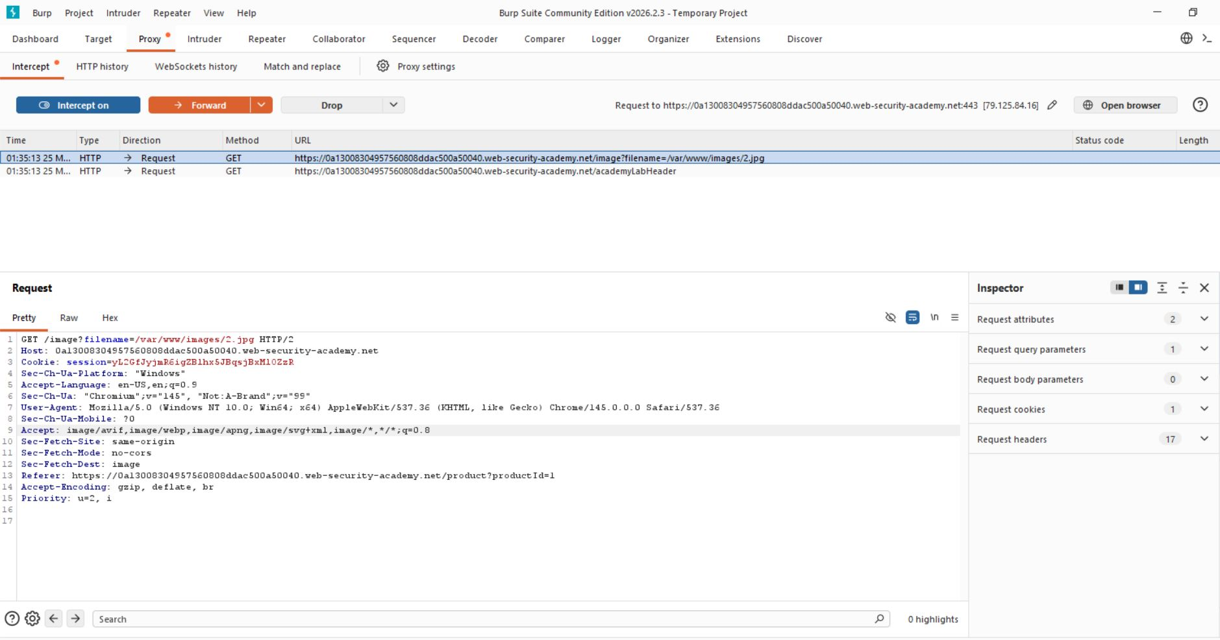

Step 2: Inject Mixed Path Traversal Payload
Replace:
filename=product.jpg
With:
filename=/var/www/images/../../../etc/passwd
GET /image?filename=/var/www/images/../../../etc/passwd HTTP/1.1
The server returns sensitive system file contents:
root:x:0:0:root:/root:/bin/bash
daemon:x:1:1:daemon:/usr/sbin:/usr/sbin/nologin
www-data:x:33:33:www-data:/var/www:/usr/sbin/nologin

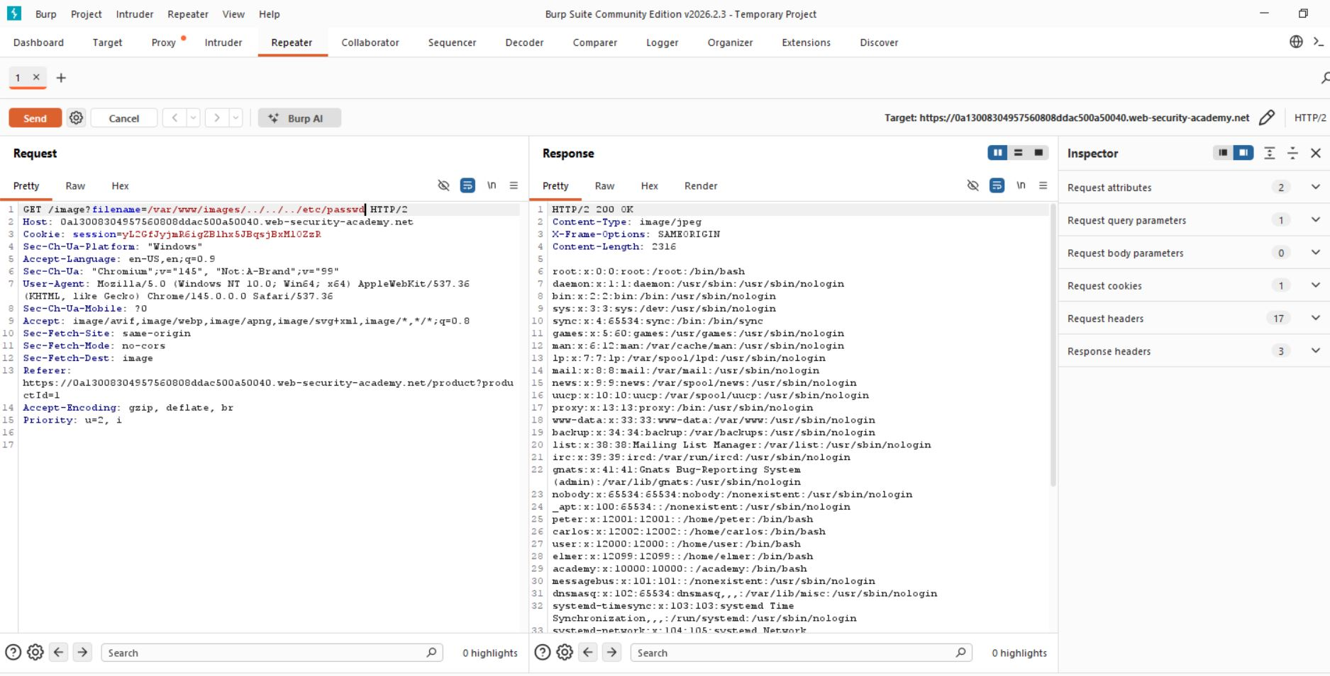

Step 3:- Analyze Response
The server responded with the contents of the /var/www/images/../../../etc/passwd

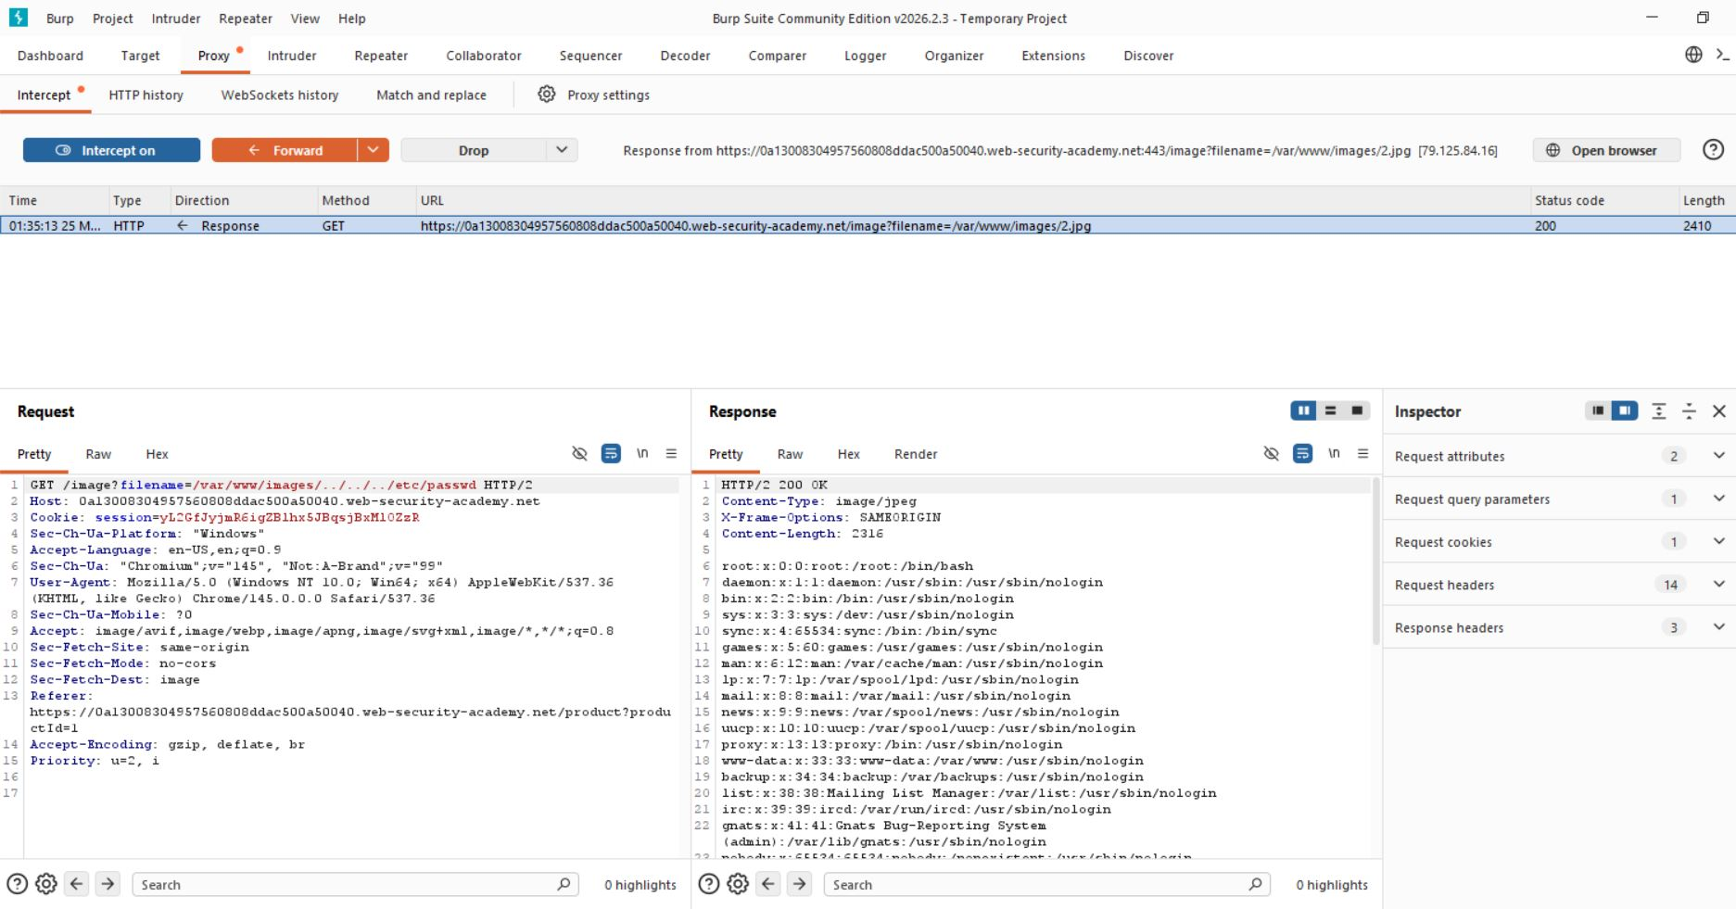
Step 4:- Lab solved successfully.
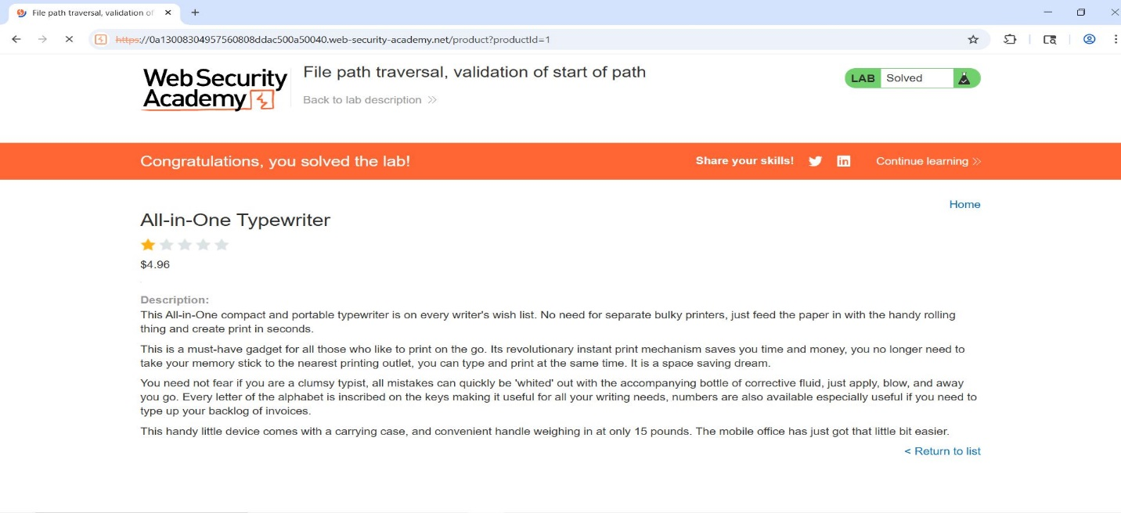

- The application successfully returned sensitive system file contents, confirming that directory traversal is possible.

